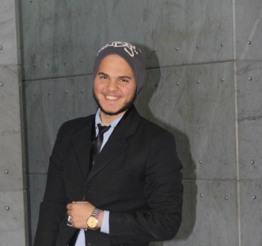
AlTaiar St. Gerace, Ashmoon, Monufia Governorate
Fb.com/mohammed a. moneem – p7oenix@gmail.com - (0020) 1100428449
Mohammed Abd El Mone'em El-Said

Qualifications Summary | - Attind Medical Anlysis cource in cairo university. (Jan 2018)  - Attend clinical pharmacy cource in cairo university. (Jan 2018)  - Attend O.T.C cource in cairo university . (Jan 2018)  - Attend First Aid Box cource in cairo university . (Jan 2018)  - Attend Nutration cource in cairo university . (Jan 2018)  - Attend Hummn resource cource in cairo university. (Jan 2018)
Skills and Language | Computer Skills  Windows - Internet  Word  Marketing  Sociability and dealing with other  Languages  Arabic: Mother tongue.  English: Good in both written and spoken.
Student  activities and volunteering | - Head Assisant of Humman Resource Committee at Innovation team
Education | - Samadoom institute of Al Azhar with certificate with grade (87%).  - Student at faculty of science at Al Azhar university Asyut branch  - Studding special biology

